Geometry: Unit 3, Lesson 1
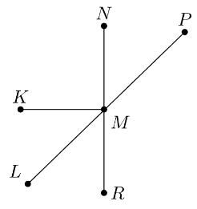
- $\overline{KM}$, $\overline{NR}$, and $\overline{PL}$ are shown, where $\overline{NR}⊥\overline{KM}$. What describes the relationship between $∠LMR$ and $∠RMP$?

Supplementary angles

- Given $m∠QAZ=79°$, what is the measure of an angle supplementary to $∠QAZ$?

$$101°$$

- Are the given two angles complementary?
$m∠IJK=89°$ and $m∠JKL=89°$

No

